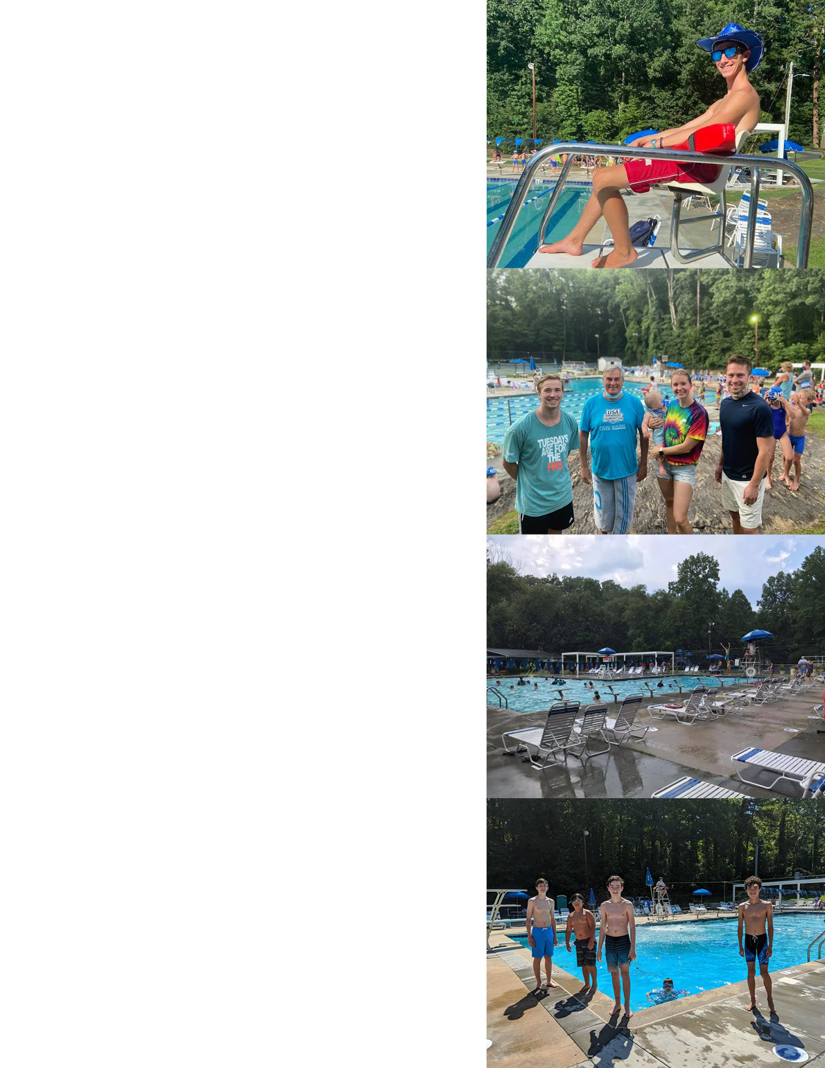
21 Certified Lifeguards

Northbrook Country Club
Annual Meeting
State of the Club Report
Sunday, October 11, 2020 | 4:00 pm, poolside

Notable Works and Accomplishments
- Created a new logo to reflect our multi-faceted membership with a nod to our mid-century architecture.
- Established a Rules and Governance Committee
  - Reviewed governing documents:
    - Updated bylaws to make our policies and procedures more efficient and transparent as well as to be consistent with what had become operating procedure for the Club during the last few years
    - Updated the Articles and filed them with the Secretary of State on March 10, 2020
Created Accessibility Committee
and wrote our Values Statement

    - Wesley Gelb is serving as the Registered Agent- updated information was also filed with the Secretary of State on March 10, 2020
    - Hired outside counsel to assist us in preparing to open the pool during the pandemic
- Hired Maddison Cason, Certified Public Accountants to conduct an audit of our books. All were found to be in order.
- Established rules and protocols to open the club in the pandemic with guidance from CDC and NCDHHS
  - Implemented successful sign-up system
  - Improved cleaning procedures
  - Hired additional staff
Increased Rental Income
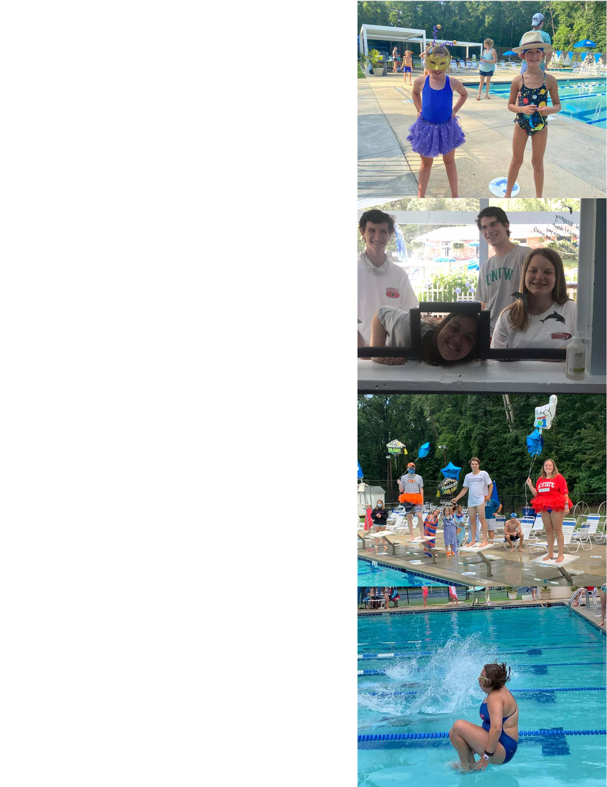
  - Adjusted rules for distancing and safety
  - Created signage for clarity and reinforcement
  - Opened with special hours for high risk members
  - Hosted a graduation ceremony for our seniors
- Created a club Values Statement to reinforce our mission and reiterate our shared values of diversity, equity, and inclusion
- Completely overhauled the Snack Bar in anticipation of the new and improved space in the renovated clubhouse
  - Implemented credit card payment system
  - Implemented new inventory system
- Successfully ran Swim and Dive Teams in the pandemic
  - One of the only pools that had regular practices, intra and inter-squad meets
  - Swim Team had 120+ members
    - Ran 6 meets
  - Dive Team had 40+ members
    - Ran 4 meets
- Although we ended our 20 plus years rental relationship with Triangle Singles, we were able, with Jonathan Watson’s help, to capitalize on pool scarcity this summer and rent the pool during off hours to the Marlins of Raleigh Swim Team. Their income exceeded $14,000.
- Created a committee to address accessibility
Hired additional staff from our NBK family to assist with COVID procedures

  - Approved a lift for the pool to be in use 2021
  - Identified areas to improve accessibility for all members and guests
  - Planned for training of staff in applicable areas
- Created a Long-Range Committee
  - Created and approved clubhouse renovation plans
    - Hired New City Design Group to serve as architects, project managers, and engineers
    - Worked with Treasurer to secure finding for the project
    - Displayed plans for membership
- House and Grounds Improvements
  - Added additional shade structure and retaining wall
Happy Graduation, Seniors!
  - Put in sidewalk from North Hills Drive to parking lot
  - Put in stairs from lower to upper parking lot
  - Replaced old and/or damaged tables and umbrellas
Created and approved clubhouse renovation plans

33 Staff Members- Successfully manage the pool in house, proudly hiring primarily from member families and friends
- 6 Managers
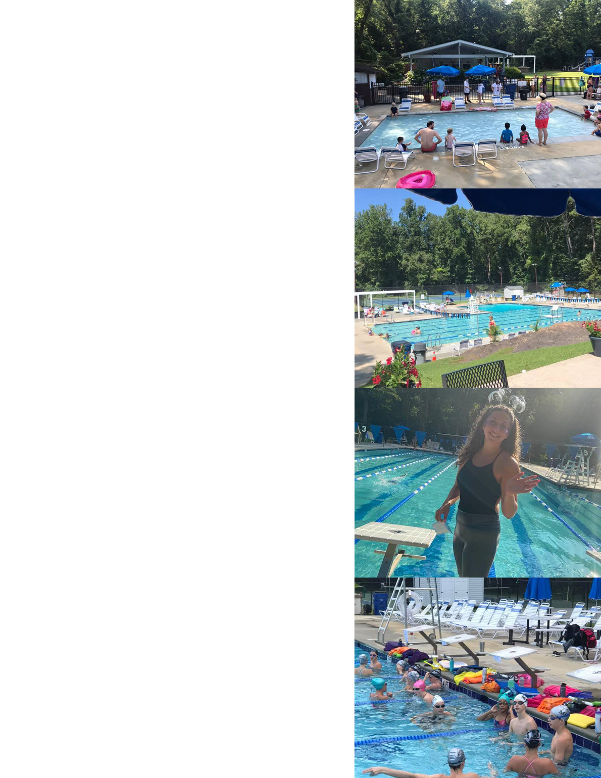
- 21 Certified Lifeguards
- 14 Snack Bar/Check-in attendants
377 Memberships- Currently have a waitlist of 70+ families
- 342 Family
- 6 Senior Couple
- 3 Senior Single
- 12 Single
- 15 Board
Added shade, stairs, and sidewalks

By-laws, Values Statement, and contact information can be found on our website www.northbrookpool.com

Contact us- contact@northbrookpool.com

Board Members

Executive Committee:
Jennifer Moran- Board Chair, Long-Range Planning
Elizabeth Smith- Chair-Elect, Membership
Jonathan Watson- Past-Chair, Socials
Andy Adams- Treasurer
John Elliot- Secretary
Hosted more social events

Josh Barmer- House and Grounds
Keely Byars-Nichols- Communication
Wes Gelb- Rules and Governance
Jenn Marks- Snack Bar
Tracy Pilson- Teams
Eric Stevens- Personnel
Jeff Walker- Rentals

Gail Brenner- bookkeeper

Respectfully Submitted,

Jennifer Moran
October 11, 2020

Awesome Swim and Dive Season!

